

METU EEE

STATIC ENERGY CONVERION-I

HARDWARE PROJECT REPORT

Yunus Cem Duman-2093680

Mert Aydın-

Burak Kemal Kara-2114734

**Date:15.01.2020**

Contents

1. Introduction 3

2. The Description and The Aim of The Project 3

3. Design of the Project 4

3.1. The Main Topology 4

3.2. Thermal Design 5

3.3. The Implementations for Bonuses 12

3.3.1. H-Bridge 12

3.3.2. PCB Implementation 12

3.3.3. Industrial Box 12

3.3.4. Closed-loop Voltage/Current Control by Arduino 12

4. Test Resuls 12

5. Conclusion 12

6. References 12

# 1. Introduction

The demand for the electrical power over the world increased by increasing population. Electrical vehicles, smart houses, wind trubines etc. , which has inevitable to improve by this increasing population, has made a great influence on the power systems and changed the traditional understanding of power system. These developments made the power systems and power electronics area much more important than before. These areas are completes each other. However the project is more about the power electronics area. The power electronics area has a huge scope of electrical engineering.This area contains rectifiers, inverters, DC/DC converters, motor drive circuitries, electrical vehicles, generators, motors etc. These circuitries are commonly used in our daily life and it is developing everyday. In order to understand and contribute the developments at this area, it is essential to have a good understanding of basic topologies of this area. So this project is all about having an understanding of one of the very basic applications of the power electronics area.

This project is a work of full understanding of DC motor drive. The main idea is to drive the DC motor that is applicable at laboratory, by using a variac, the device for arranging the voltage level that is taken from the grid and control the DC motor’s speed. The drive circuitry is a combination of some of the topologies that this discipline covers such as rectifier circuitry and DC/DC converter etc.

# 2. The Description and The Aim of The Project

The project is to design a DC motor drive that is applicable at laboratory and can be seen at Figure 1.

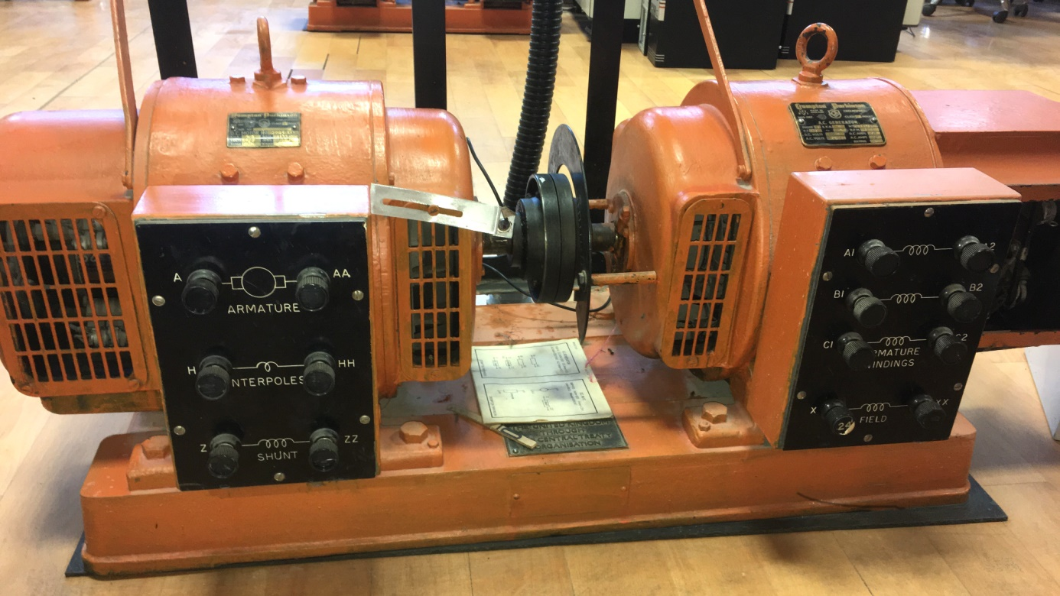

Figure 1:The DC Motor(Crompton Parkinson brand)

This motor is an experimental type motor and it’s rating values can be seen from the below figure.

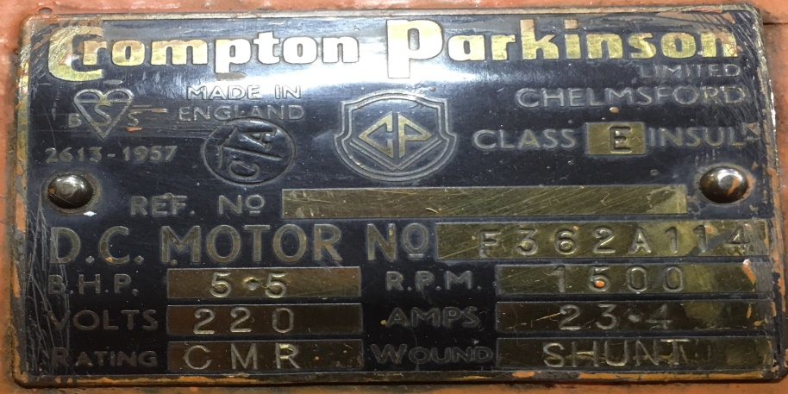

Figure 2:The Ratings of DC Motor

The motor has;

**-Armature Winding**: 0.8

**-Shunt Winding**: 210 Ω, 23 H

**-Interpoles Winding**: 0.27 Ω, 12 mH

**-Inertia**: TBA

In order to drive this DC motor many circuit topology can be used. However due to simplicity and applicability of the diode rectifier and a buck converter connected topology is choosen which can be seen at Figure 3.

# 3. Design of the Project

## 3.1. The Main Topology

The main topology of the design is a three phase diode rectifier and a buck converter. The main working principle of the drive can be examined one by one. Firstly three pahse diode rectifier converts the AC voltage that is supplied by variac and converts it to DC voltage. Changing the variac voltage in order to control the speed of the motor is restricted. So it is impossible to control the DC voltage applied to motor by just using three phase diode rectifier. So the buck converter is used in order to control the DC voltage level that is applied to DC motor. According to the duty cycle applied to the switch (MOSFET) of the buck converter topology, can be seen at Figure 3, the voltage level that is applied to DC motor can be controlled. So that means another circuitry is necessary to drive the MOSFET also. So 555 timer is used in order to drive the mosfet of the buck converter. However that was not enough either. 555 Timer circuitry can not drive the mosfet circuitry alone, so octocoupler circuitry is necessary.

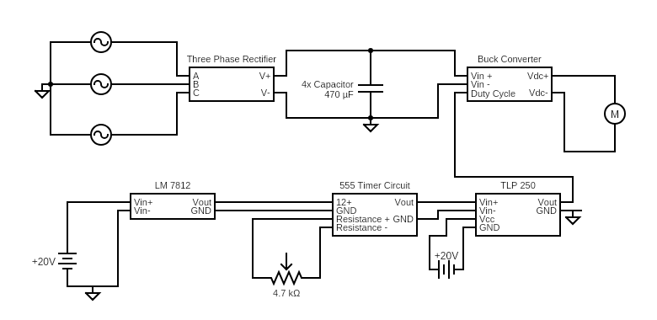

Figure 3 Overall Hardware scheme

### 3.1.1. Three Phase Rectifier

## 3.2. Thermal Design

Thermal design one of the most important considerations in the power electronic circuits because there a lot of power handling electronic components and unfortunately, these devices does not work at %100 efficiency. Therefore, some of the losses should be dissipated as heat through these components. However, these devices can not tolerate that much heat by itselves. Thus, additional mechanical parts should be integrated with them to ease the dissipation of the heat. Additionally, not just because the safety of the components, but also, performance and life-time of the components are mostly determined by thermal design so, it should be implemented for those reasons.

For our circuit, there are two parts that dissipate heat significantly, These are rectifier unit, and buck converter. Since we have one compact rectifier module and also diode and mosfet which form buck converter connected to same heatsink, two heatsinks are used totally.While selecting heatsinks, not just driving at no load is considered but also robustness bonus is considered. Therefore, calculations are made for both requirements as follows.

**Calculations:**

for the first, the heatsink for buck converter is calculated

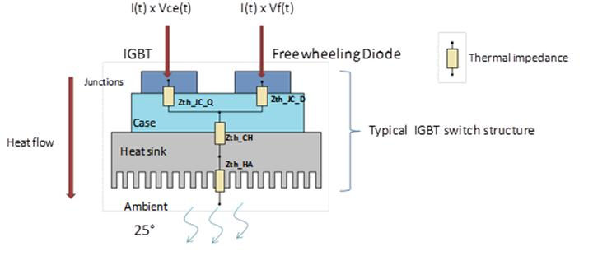

figure??: thermic lumped parameter model of the buck converter.

* First we assume the thermal contact between the heatsink and component are neglible so, we neglect that part.
* Secondly, we should calculate total power loss to select the suitable heatsink.

For that purpose, we should look back to datasheet of the diode and IGBT to obtain the pararameters for both conduction losses and switching losses.

firstly , we use DHG30I600PA diode and its parameters are as follows:

**(*) V**fo=1.17V.

(**) rF=32 mΩ.

And for the Switching losses,

(we already know the fs=500Hz and Vr =200V at most)

We just need to find Qr from following graph.

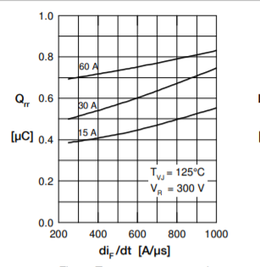

Figure?? Qr vs dif/dt from datasheet.

From above figure we Assume Qr as 0.3 uA at worst situation because the current that pass through the diode never exceeds the 10A.

So, we can insert those values to the equations,

Pcd= (1.170.032)10(we assume at most diode conduct 10 A which is still lover than rated operation of the project

Psd=0.30 (since frequency is low it is normal)

Psd+Pcd=15 Watt at total contribution from diode.

Now we can calculate the losses for the IGBT.

For the conduction losses of IGBT,

**Vce**=1.6 V (collector emitter sat. voltage)

**If=**10 A ( for a safety margin. normally it depends on duty cycle)

Pic= 16 Watt .

For the Switching losses, we should obtain the energy required for opening and closing.

We choose the “IGW30N60T” IGBT and from its datasheet, ETOTAL=1.8 mJ

the frequency of operation is around 500Hz and that energy will be given and taken in one interval of operation. Therefore, we should multiply fS with the ETOTAL to find switching loss.

Pis=fS (it expected since frequency is so low)

Therefore, total contribution from IGBT is 17 watt.

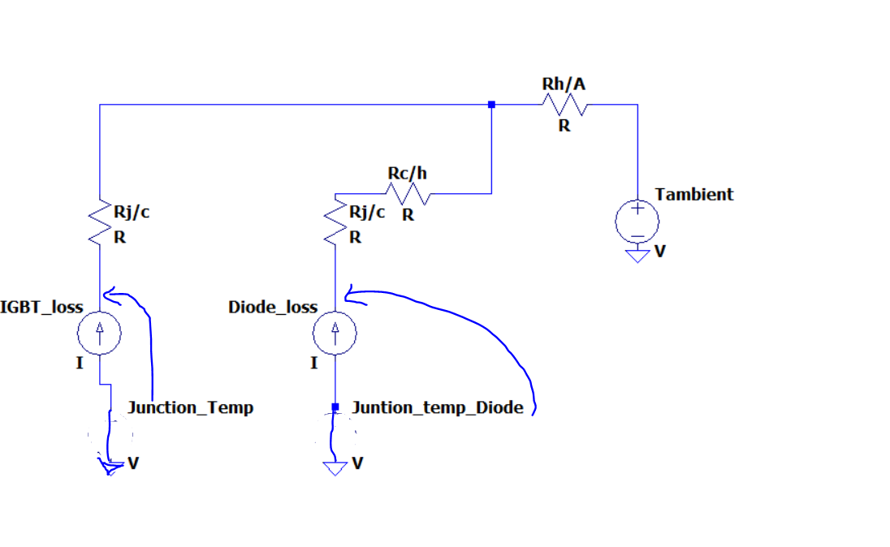

Figure??: detailed lumped model of thermal design.

* Thirdly, we should find the thermal resistances from the datasheets and guessing a reasonable heatsink value from these results.

**Rj/c(diode)=0.7 C/W , Rc/H(diode) =0.5 C/W Rtotal=1.2C/W**

**Rj/c(IGBT)=0.8 C/W**

if we assume heatsink has 1.0 C/W thermal resistance then the junction temperatures will become as below:

Tj(diode)=25+15321=75 C.

Tj(IGBT)=25+170.8+321=70.6 C.

These are far less values that the maximum operating junction temperature which is 175 C degrees so, we select a heatsink which has 0.9 C/W thermal resistance to realize the that idea.

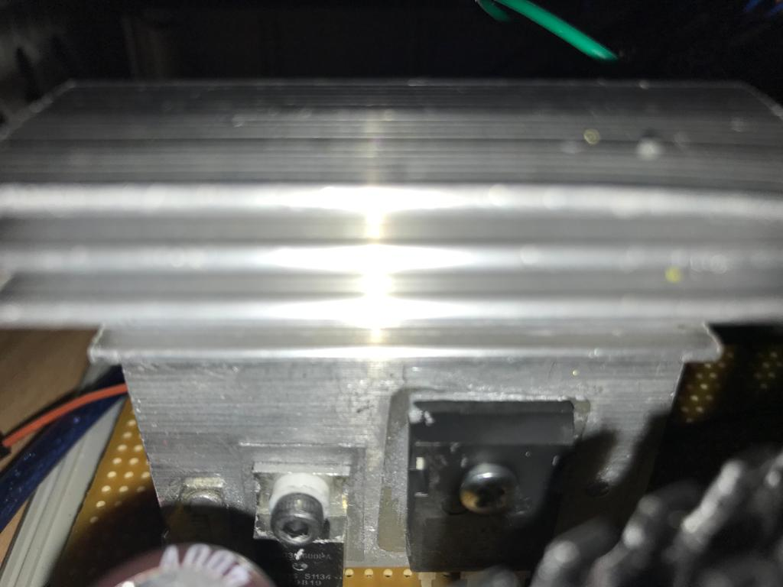

Figure??: Resultant hardware configuration of thermal design (for buck converter)

For the Second, we will calculate the heatsink required for the Three-phase full bridge rectifier,

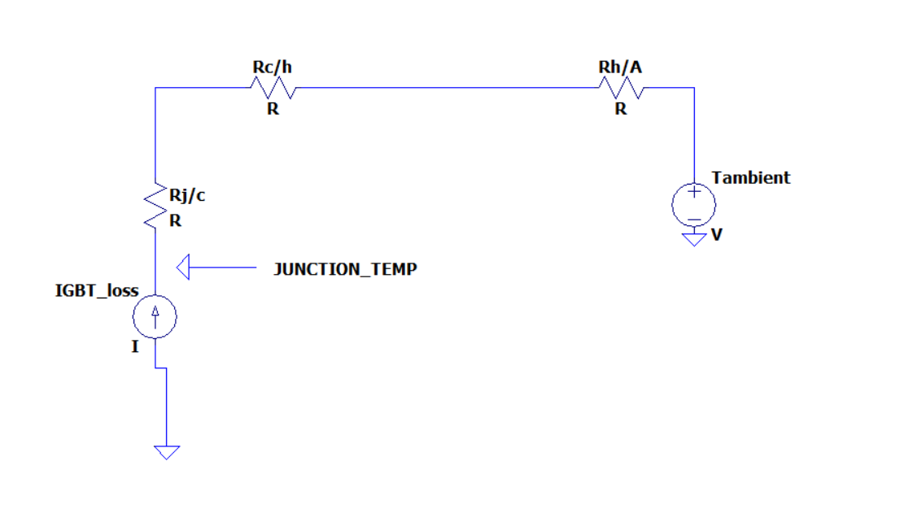

Figure:?? the detailed lumped model of the bridge module.

So, Again we should calculate the losses and applying the same procedures above for the selecting a suitable heatsink.

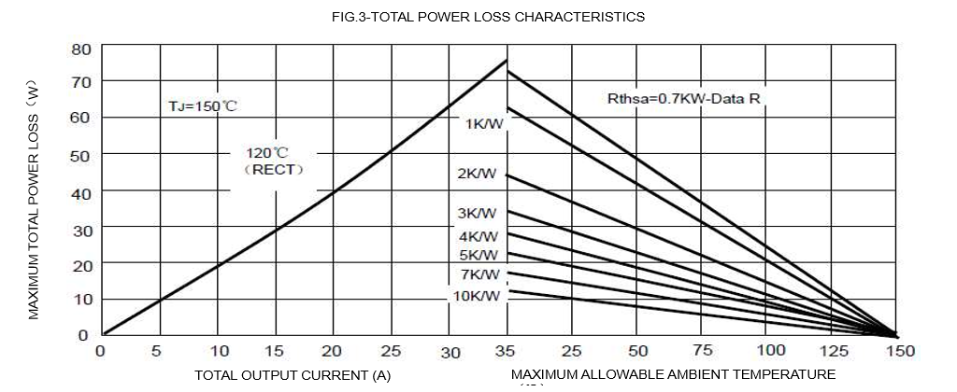

Figure??: power loss characteristic of the bridge module. (from datasheet)

Since we have a bridge module rather than six single diodes, accessing the datasheet of the diodes inside of the module is not possible. In datasheet provided for complete module includes some general power loss characteristic as in the figure above. this curve gives the maximum power loss therefore, it will be safe to use it although it may results with unnecessarily large heatsink.

Ploss= 20 Watt (at 10A output).

So, it is now time to find thermal parameters from the same datasheet.

**Rj/c**=1.16 C/W.

**Rc/h=**0.2 C/W.

So, we try with a 1.8C/W heatsink and result will be:

Tj=(1.16+0.2+1.8)20=88 C

So, it is again relatively safe for the operation of this project.

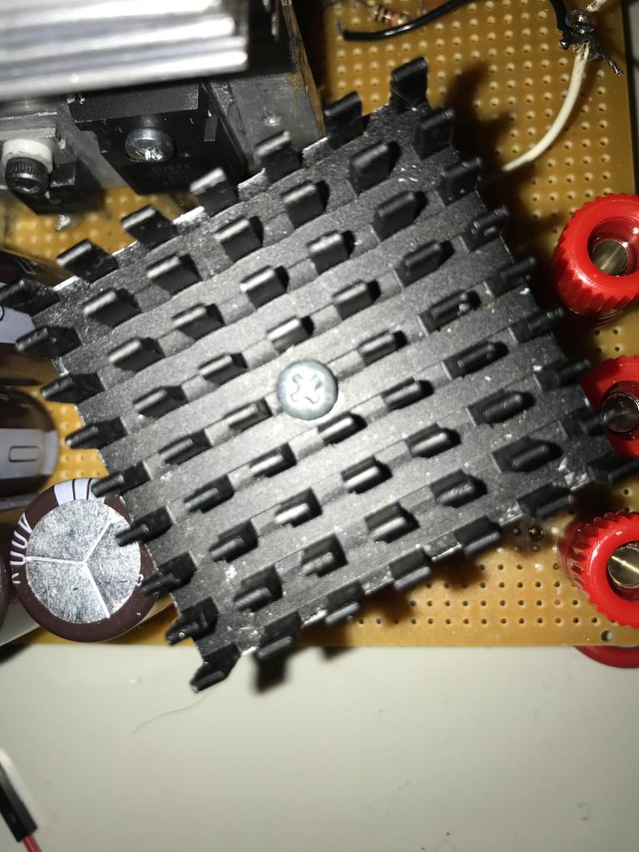

Figure:?? the heatsink for the full bridge rectifier.

<https://www.aliexpress.com/i/32634872516.html>

## 3.3. The Implementations for Bonuses

### 3.3.1. H-Bridge

### 3.3.2. PCB Implementation

PCB (Printed Circuit Board) is a circuit board which is widely used in every electrical and electronics area. At every professional circuit design, PCB design is inevitble. The reason for that are the connections of the components are copper paths, i.e. the connections are stationary and requires less volume, the components of PCB has less volume and it is more cost friendly when the circuit is massly producted. The copper paths are scraped to layers, i.e. the surfaces of the PCB. Depending on the complexity of the circuitry, the number of the layers may change, i.e. single-layer, double-layer, multi-layer. The more layer means it is more costy. So the less number of layers are used in PCB makes it more cost friendly. This project’s designed PCB is single layer since the circuitry is not complex. Of course, depending on the usage area, the shape and the volume of the PCB varies. For instance, according to the flowing current magnitude of a copper path, the wideness of the path changes. In other words, more current requires a wider copper path. The PCB design is made by considering these features and the design is made by using EasyEDA software as can be seen from the below figure;

1

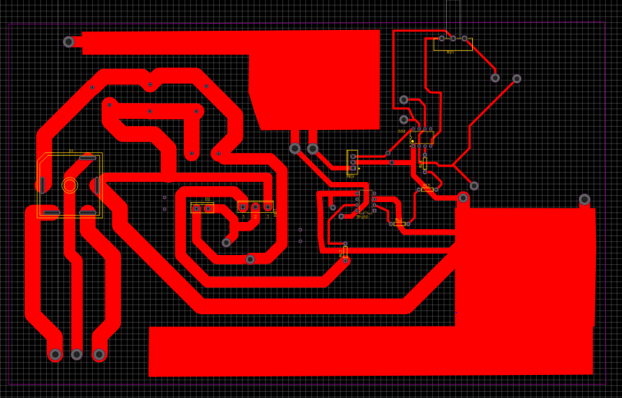

2

3

4

Figure 3:The PCB Design of DC Motor Drive

**1-**The copper areas that is used for positive DC voltage(Vcc) and ground(GND) connections. The reason for the huge amount of areas used is that the most current flowing areas of the circuit are DC supply and ground connections. If these does not have enough wideness the circuit may get damaged.

**2-**The connections of the 555 timer and octocoupler. The wideness of these connections are less relative to the left side of the circuit since it carries less amount of current.

**3-** The connections of the power electronics circuit, diode rectifier and buck converter. The wideness of these connections are greater relative to the left side of the circuit since it carries more amount of current.

**4-** The components. The components can be seen from Figure X easily by looking into the yellow edges except capacitors since they do not have an exact package type.

The routes (paths) wideness changes according to the the magnitudes of the current that is flown as mentioned before. The left side of the PCB, which can be seen from Figure X, is power electronics circuitry, i.e. diode rectifier, power mosfet, power diode etc. , and the right side of the circuitry is gate drive circuitry of the switching mosfet, i.e. octocoupler and 555 timer. So that is the reason for the difference between the paths wideness of right side and left side. Of course, the wideness of the paths are not determined blindly. According to the tickness of the copper routes () of the PCB, a calculation machine, a webside [x], is used in order to determine the size of the paths.

The components that is used in the circuit is determined before designing the PCB. So according to the choosen and bought components, the packages of the components are determined. However the capacitors does not have a certain package type. Therefore, the a package for these capacitors are not used. Instead, the measurement of the sizes of the capacitors are determined and the holes are placed fort he capacitors’ legs for implemeting capacitor places in PCB design.

The 3D wiev of the design and the ordered PCB can be seen from the Figure X and Figure X.

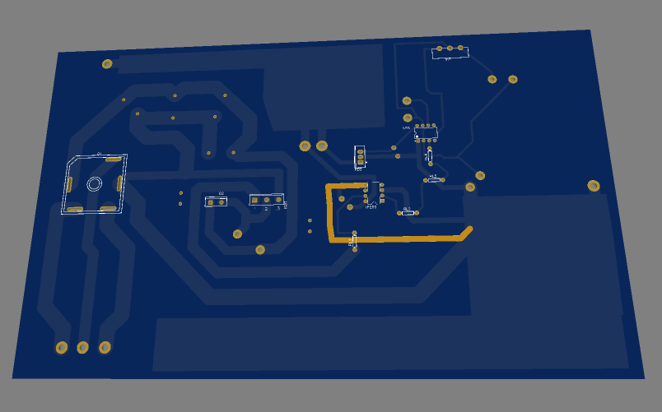

Figure X:The 3D view of the PCB design

**Figure X:**The PCB of the DC Motor Driver

The sizes of the PCB are ….cm length, ….cm height and …...mm thickness. Although it may seem huge, in order not to harm the circuit is much more important for this project. As in every application of engineering, if a feature of the design is developed, another feature needs to be waived. That is an example for this rule.

### 3.3.3. Industrial Box

### 3.3.4. Closed-loop Voltage/Current Control by Arduino

# 4. Test Resuls

# 5. Conclusion

The electrical machines has a huge part in our lifes. They are used in a wide area from generating power to electrical vehicles. In order to use these devices, it is compulsary to design and use their driver circuits. These driver circuits are combinations of different topologies from different usage areas such as control engineering, power electronics engineering, electronics engineering etc. So this project’s scope consists of these driver circuits. The driver circuit of a DC motor is designed by determining the simpliest topology, invetigating it and designing it with a full understanding of these topologies. As DC motor drive, three phase diode rectifier is used in order to convert AC voltage of variac and buck converter is used in order to control the DC voltage that is applied to DC motor. The switching MOSFET that is a part of buck converter required a driver circuit as well. In order to drive the gate of the MOSFET, i.e. a PWM(pulse width modulation) signal is used in order to arrange the level of DC voltage applied by the duty cycle raito, 555 Timer circuit and octocoupler circuit is used. Although only a single bonuses’ point is earned, almost every bonus is tried to be implemented. The reason for not to achive these bonuses is the lack of time for the demonstration. However, these bonuses were quite instructive and become a good practice. Additionally, this project has a good contibution to team work skills and the design steps from investigating to implementing.

# 6. References

<https://www.aliexpress.com/i/32634872516.html>